Episode 605: The First Law of Thermodynamics

An introduction to thermodynamics.
Lesson Summary
- Discussion: The First Law and energy conservation (15 minutes)
- Discussion: Understanding the equation (15 minutes)
- Demonstrations: Expanding and compressing gases (20 minutes)
- Discussion: Adiabatic and isothermal changes (10 minutes)
- Student questions: On the second law (20 minutes)

Discussion: The first law and energy conservation
It is very easy to trivialise the ideas here and forget just how important thermodynamics has been in the development of physics. It is often worthwhile exploring this issue from two angles.
The first is historical and the following brief outline should serve as the basis for further study: In the late 18th century Benjamin Thompson (Count Rumford) asserted that heat was not a fluid (caloric) stored within materials but was associated with motion in some way. This was deduced from seeing that apparently limitless amounts of heat were generated when boring a cannon, especially as the drill became blunter. However, as this predates a good knowledge of atoms and molecules it is unclear what is moving. In the early 19th century James Joule performed quantitative measurements to compare the amount of mechanical work and heat that would raise the temperature of a known quantity of water by the same amount. This is the basis of the first law of thermodynamics. Recognition is also given to Julius Mayer, a physician, who noted on trips to the tropics that sailors’ venous blood was redder than when in colder climates, and so contained more oxygen. He deduced that, in the hotter climate, less energy was needed to keep warm and so less oxygen was used from the blood. He was able to link this to the amount of food needed and so made major headway in our understanding of work and energy.
The second approach is more philosophical. Students have had the idea of conservation of energy drilled into them from an early age but few question why we believe it. Ultimately it rests on experiment and there were at least two occasions in the 20th century when the advent of quantum theory and the discovery of new particles made even top scientists question the validity of the law at a level of atoms and below. The first instance involves Compton Scattering, where light scatters off an electron and changes energy and momentum. In the early versions of the quantum theory, conservation of energy and momentum did not seem to both hold at the same time. Even Niels Bohr was willing to sacrifice conservation of energy. It turned out, of course, that the problem lay in the old quantum theory. A second example comes later in the century. In beta decay the beta particle can carry off a variable amount of energy and some appears to be lost. Again scientists were willing to conclude that energy is not conserved at a microscopic level. However, the discovery of the neutrino restored the energy balance.
So what does the First Law say? In words, the internal energy of a body (such as a gas) can be increased by heating it or by doing mechanical work on it. In symbols:
Δ U = Δ Q + Δ W
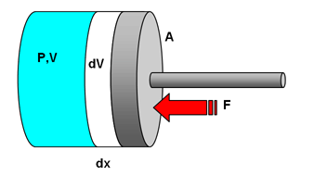
Note that internal energy U is not the same as the energy stored thermally. They are quite distinct concepts. Many text books tend to imply that energy stored thermally, what used to be referred to as heat and 'internal energy' are equivalent.
The sign convention here is that if DU is positive the amount of internal energy increases. This means that Δ Q stands for the heating of the system and Δ W for the work done on the system. This is known as the physicists' convention. You may come across text books that use the engineers' convention. Energy put into a system is positive, and the work output is also taken as positive. Providing you are consistent which convention you apply, all will be well.
Episode 605-1: Thermodynamics (Word, 47 KB) - see end of document

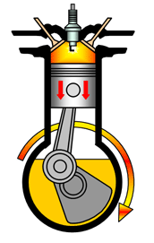

Discussion: Understanding the equation
Practise using the equation and sign convention. Ask what happens to the internal energy as a gas is compressed or if it expands against an external pressure (such as air).
To compress a gas, you have to do work on it. This transfers energy to its particles, so they move faster – the gas is hotter.
If a gas expands against the atmosphere, it must do work to push back the atmosphere. Its particles lose energy and move more slowly, so its temperature falls.
How would such changes be observed? That is, what does a change in U represent? Note that it affects not just temperature but also possibly the state of a gas.

Demonstration: Expanding and compressing gases
There are a number of possible demonstrations of the First Law. Simple and dramatic ones include commercial devices that let you compress a cylinder of air rapidly and ignite a small wad of cotton. A more conventional alternative is to compress the air in a bicycle pump and to observe the rise in temperature.
Episode 603-1: Warming up a gas by speeding up its particles (Word, 46 KB) - see end of document

The reverse effect is to demonstrate the formation of dry ice from a CO₂ cylinder, letting the gas expand against air pressure. You will need to consult the relevant safety documents for this.
Episode 605-2: Formation of dry ice from a carbon dioxide cylinder (Word, 79 KB) - see end of document

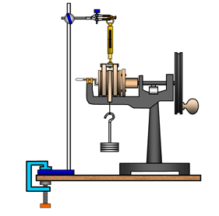
You may also have the equipment for a quantitative analysis. This usually involves a friction drum or wheel and compares mechanical work done against a friction force to the rise in temperature of the system. An alternative system allows mechanical work to be compared with energy supplied electrically.
Episode 605-3: Doing mechanical work (Word, 48 KB) - see end of document

Episode 605-4: Mechanical and electrical heating (Word, 50 KB) - see end of document

Discussion
If your specification requires it you could then go on to look at examples of adiabatic changes (in which no energy flows in or out – either an insulated system or one, like the bicycle pump, where the change is fast), isothermal changes (where the temperature is kept constant, so Δ U is zero, usually involving a heat bath to extract or supply energy) and constant volume or isochoric (so no work can be done, but energy can flow in or out).
This simulation of an adiabatic change may be useful, but beware the different notation used for internal energy:
Boston University Physics Department

Student questions
The conservation of energy underlies our modern understanding of physics but also has important implications for our use of energy resources. In particular, the idea that mechanical working disspates to the surroundings is a very practical issue. With little quantitative work in this section, students could be set questions on sensible use of energy resources or the mechanics of power stations. Try to get them to emphasise the difference in meaning between conserving energy as in not wasting it and the scientific meaning of conservation.

Episode 605-1: Thermodynamics

The study of thermodynamics resulted from the desire during the industrial revolution to understand and improve the performance of heat engines such as the steam engine and later, the internal combustion engine.
This section contains many references to heat and temperature so it is important to define these terms. Strictly speaking:
Energy is transferred between two objects of different temperature by heating.

Internal energy is the energy stored in an object because of the motion of its constituent particles due to its temperature, plus the mutual potential energy of the particles due to the forces between them.

When a gas is heated two things may happen:
- the internal energy of the gas may increase
- the gas may do external work

Considering this in another way, the internal energy of a gas will increase by either:
- heating it or
- doing work on the gas by compressing it

This leads us to a proposal know as the First Law of thermodynamics.

The First Law of thermodynamics:
The First Law of thermodynamics is basically a statement of the conservation of energy. Very simply it states that:
You can't get something for nothing

Put a little more formally:
The energy content of the Universe is constant

This means that there is a finite amount of energy in the Universe and although this energy can be stored in different ways the total amount never changes – if we want to transfer energy in a particular device, then the energy stored somewhere is depleted, and the energy stored somewhere else increases.
If we consider the First Law in equation form as it applies to a gas then:
Increase in internal energy (ΔU) = Energy transferred by heating the gas (ΔQ) + Energy transferred by working on the gas (ΔW)

First law of thermodynamics: ΔU = ΔQ + ΔW

Note that ΔU represents both the change in the energy of the gas stored kinetically (due to an increase in molecular velocity) and the change in energy stored in the electrostatic field (due an forces overcoming intermolecular forces between molecules). The change in energy stored in the electrostatic field is zero for ideal gases (because ideal gases are assumed to have no intermolecular forces acting between the particles) and negligible for most real gases except at temperatures near liquefaction and/or at very high pressures.

Work done by an ideal gas during expansion
Consider an ideal gas at a pressure P enclosed in a cylinder of cross-sectional area A.
The gas is then compressed by pushing the piston in a distance Δx, the volume of the gas decreasing by ΔV. (We assume that the change in volume is small so that the pressure remains almost constant at P).

Work done on the gas during this compression = ΔW
Force on piston = P A
So the work done during compression = ΔW = P A Δx = P ΔV
dV
dx
P,V
F
A

The first law of thermodynamics can then be written as:

ΔU = ΔQ + ΔW = ΔQ + P ΔV

External reference
This activity is taken from Resourceful Physics

Episode 605- 2: Formation of dry ice from a CO₂ cylinder

You will need
- CO₂ cylinder with siphon tube
- dry ice attachment (e.g. Snowpack or Jetfreezer) or a nozzle with a small hole
- a cloth
- insulating gloves
- safety notes

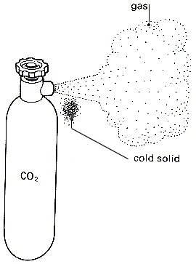

What to do:
If the carbon dioxide is released quickly through a small hole then a small quantity of dry ice may form, as illustrated above.
The quantity of dry ice is increased if a cloth is held loosely around the hole
A snowpack attachment (see below) allows the production of dry ice pellets.

Safety
Wear safety spectacles
Remember to wear insulating leather gloves when handling dry ice.
(See also CLEAPSS Laboratory Handbook section 11.2)

You have seen:
The rapid expansion of the gas produces cooling.

Practical advice

CO₂ cylinder (siphon type)

Uses
Dry ice has many uses. As well as simply watching it sublimate, you could also use it for cloud chambers, dry ice pucks, cooling thermistors and metal wire resistors in resistance experiments, and experiments related to the gas laws. Don't be tempted to get a small cylinder - it will run out too quickly.

What type of cylinder, where do I get CO₂ and what will it cost?
A CO₂ gas cylinder should be fitted with a dip tube (this is also called a ‘siphon type’ cylinder). This enables you to extract from the cylinder bottom so that you get CO₂ in its liquid form, not the vapour.
NOTE: A plain black finish to the cylinder indicates that it will supply vapour from above the liquid. A cylinder with two white stripes, diametrically opposite, indicates it has a siphon tube and is suitable for making dry ice.
A cylinder from British Oxygen will cost about £80 per year for cylinder hire and about £40 each time you need to get it filled up. (The refill charge can be reduced by having your chemistry department cylinders filled up at the same time).
If the school has its own CO₂ cylinder there will be no hire charge, but you will need to have it checked from time to time (along with fire extinguisher checks). Your local fire station or their suppliers may prove a good source for refills.

CLEAPSS leaflet PS45 Refilling CO₂ cylinders provides a list of suppliers of CO₂

A dry ice attachment for the cylinder
Dry ice can be made using an attachment that fits directly on to a carbon dioxide cylinder with a siphon tube. Section 11.2 of the CLEAPSS Laboratory Handbook explains the use of this attachment (sometimes called Snowpacks or Jetfreezers)

VWR International sells Snowpacks through its UK distributor. The version that makes 30 g pellets of dry ice is catalogue number 3285042/02

Phillip Harris sells similar products. See their catalogue, (http://www.philipharris.co.uk/ )

Safety
Wear safety spectacles
Remember to wear insulating leather gloves when handling dry ice

External references
This diagram is taken from Nuffield Revised Physics section K
The practical advice is taken from http://www.practicalphysics.org/go/Apparatus_348.html

Episode 605- 3: Doing mechanical work

This experiment shows that mechanical work produces a temperature rise.

You will need
- Friction apparatus (see above)
- spring balance (Newton)
- 100 g masses and hanger
- retort stand, boss head and clamp
- G Clamp
- student to turn the handle

What to do:
Ensure the thermometer is fitted correctly and has been in the apparatus for sometime so thermal equilibrium has been reached.
- Record the starting temperature
- Turn the handle steadily so the spring balance reads zero. The friction then balances the weight. Count the number of turns. (Some equipment has a counter attached)
- Continue turning until the temperature has risen 5 °C.
- Record the highest temperature reached by the thermometer.
The experiment can be extended so that you could look at doubling the number of turns, does this double the temperature rise?
Alternatively you could double the weight, keeping the number of turns the same.

Calculate the work done
Work done = Force x distance travelled
Force = friction when the balance reads zero = the weight mg
Distance travelled against friction each turn = 2πr where r is the radius of the drum.
So
Work done = mg x 2πr x N where N is the number of revolutions and this gives a temperature rise which you recorded.
Repeat the calculation for the above suggestions or other suitable change.
How much mechanical work produces a 1 °C rise in temperature?

Practical advice
Ideally the apparatus should be used over the same temperature range so heating losses are the same. This is difficult to do practically in a time-limited session. The handle needs to be turned steadily so that the friction just balances the weights.
It may not take exactly the same amount of work for a temperature rise of 1 °C this is because of the points mentioned above.

External reference
The diagram is taken from Resourceful Physics

Episode 605- 4: Mechanical and electrical heating

A copper block is heated electrically and mechanically and the energy transferred for a 1 °C rise in temperature of the copper calculated.

You will need
- Apparatus for measuring Joules per coulomb
- rubber band
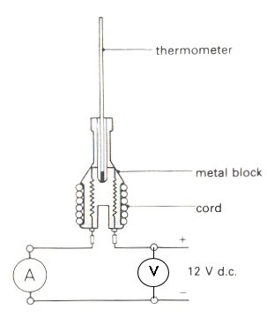
- dc voltmeter 0 -12 V
- dc ammeter 0 -1 A
- 1 kg slotted masses and hanger
- vernier callipers
- dc power supply
- leads
- thermometer 0 - 50 °C in 0.2 °C
- cord
- rubber band
- stop clock
- student to turn the handle

What to do:

- Supply energy electrically to the block so that the temperature rises about 10 degrees. The cord should be wrapped around the block 5 or 6 times so conditions are similar to the mechanical part of the experiment. Record the voltage, current, time of heating and maximum temperature rise. (The temperature may continue to rise after the power pack is turned off.)

- With the cord wrapped round the block as before set up the apparatus as below

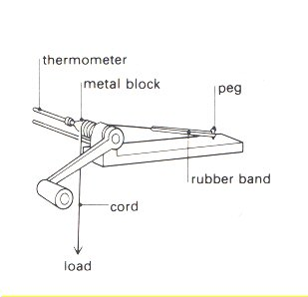

A load of about 8 kg may be needed. (Keep your feet away from under the load) The handle should be turned steadily so that the rubber band goes slack. The same temperature rise as with electrical heating is aimed for. Record the highest temperature reached. Measure block diameter

- Calculate the energy transferred electrically = V I t
and then the energy needed to be transferred to raise the temperature of the block by 1°C.

- Calculate the work required. When the rubber band is slack the friction force balances the weight.
Work done = Force x distance = weight x π x block diameter x number of turns of the handle.
Then calculate the energy for a 1 °C rise in temperature of the block.

- Compare the results.

You have seen

- Heating and working produce temperature rises in the copper.
- The energy transferred to raise the temperature 1 °C is the same by both methods.

Practical advice
It is difficult to get exactly the same temperature rise as the temperature inside the block continues to rise for a short time after heating has stopped. To have similar conditions is best, so ideally the block should be heated from the same starting to the same finishing temperature in the same time by both methods. In a time-limited situation it may be that the block is heated over different temperature ranges e.g. 20 °C to 30 °C then 30 °C to 40 °C by the other method. Obviously the heat losses will be different in each case. Some teachers start with the block 5 °C below room temperature and then heat to 5 °C above to try to cancel heat gains and losses with the surroundings. In most circumstances it is unlikely that you will have time to do this so the values obtained should be similar rather then exactly the same.
It is recommended you try the experiment beforehand so you have an idea of the settings required and the time involved.
Oil can be placed between the thermometer and copper block to improve thermal contact; this can be messy to clear up afterwards. Water is not quite so satisfactory but less difficult to clear up and in practice seems to work as well.
It is a good idea to put some foam or other suitable material so if the cord snaps you do not damage the floor. This also helps to keep feet from under the weights.
It may also help to use a smoothing unit on the output of the power supply in the electrical point.

External reference
This activity is based on Nuffield Revised Physics demonstration B2

